PROJECT DESIGN PHASE
Solution Architecture
Date | 30 September 2026
Team ID | SWTID-2026-6529
Project Name | LegalEase
Maximum Marks | 4 Marks

Solution Architecture
Solution architecture is a process that bridges the project requirements and the technology solution. For LegalEase, the architecture defines how the user interface, application logic, AI generation service and document-generation services work together to produce legal documents.
Its goals are to:
- Define a suitable technology solution for the LegalEase document-generation requirements.
- Describe the structure, characteristics and behavior of the LegalEase software to project stakeholders.
- Define major features, development components and solution requirements.
- Provide specifications that guide implementation, integration, testing and delivery.

Example – Solution Architecture Diagram
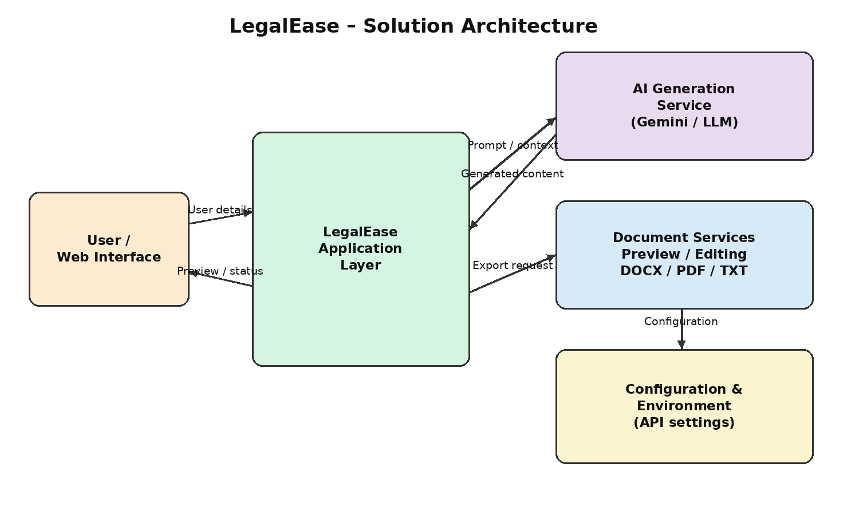
Figure 1: LegalEase solution architecture and high-level data flow

LegalEase – Solution Architecture
College: C.T.T.E. College for Women
Team: Sri Vijitha M (Team Leader); Sree Harini P; Subalakshmi P; Sumaiya A

Architecture Overview
LegalEase follows a modular application architecture in which the user interface collects legal-document requirements and communicates with the application layer. The application validates and processes the request, communicates with the configured AI service for legal content generation, and coordinates preview, editing and document export operations.

Core Architecture Components
User / Web Interface – Allows users to provide document type, parties, terms and effective date, and to preview, edit and download generated documents.
Application Layer – Receives requests, validates inputs, coordinates AI generation and manages the document-generation workflow.
Validation & Sanitization Layer – Validates required fields and safely handles invalid, incomplete, special or unsafe input before processing.
AI Legal Document Generation Pipeline – Uses the configured external Gemini/LLM service and structured prompt context to generate legal-document content.
Document Preview & Editing Module – Displays generated content for review and allows users to modify the document before export.
Document Export Module – Converts final content into supported TXT, DOCX and PDF output formats.
Configuration Layer – Manages application settings and external AI credentials through environment-based configuration.
Output Layer – Provides the generated files to the user for download and further use.

High-Level Data Flow
User → Web Interface → LegalEase Application Layer → Validation / Sanitization → AI Generation Service → Generated Legal Content → Preview / Editing → Document Export → TXT / DOCX / PDF output.
When AI processing is requested, the application sends the required document type and contextual user inputs to the configured external LLM service. The generated legal content is returned to the application, displayed for user review/editing, and then processed for final document export.

Key Requirements
- User-friendly input for document type, parties, terms and effective date.
- AI-based generation of structured legal-document content.
- Validation and safe handling of user-provided input.
- Preview and editing of generated documents before export.
- Support for TXT, DOCX and PDF document output.
- Professional document formatting including headings, terms and applicable branding/footer elements.
- Controlled handling of AI or document-generation failures.
- Secure environment-based management of external AI credentials.

Team Details
Team ID | SWTID-2026-6529
Team Leader | Sri Vijitha M
Team Member | Sree Harini P
Team Member | Subalakshmi P
Team Member | Sumaiya A

Sign-Off
Team Leader | Sri Vijitha M
Signature | ________________________________________
Date | ________________________________________
Faculty / Project Guide | ________________________________________
Signature | ________________________________________

